Lab 2
Arrays Implementation

Objective:
The objective of this experiment to get familiar with
- Arrays and its role in data structure
- Storage of data in Row major order and column major order.

Introduction:
An array is a series of elements of the same data type placed in contiguous memory locations that can be individually referenced by adding an index to a unique identifier.
For example, five values of type int can be declared as an array without having to declare 5 different variables (each with its own identifier). These values can be accessed using the same identifier, with the proper index.
int array[5];

Multidimensional arrays can be described as "arrays of arrays". For example, a bi-dimensional array can be imagined as a two-dimensional table made of elements, all of them of a same uniform data type.
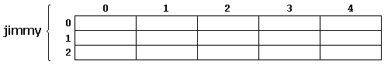
Jimmy represents a bi-dimensional array of 3 per 5 elements of type int. The C++ syntax for this is:
int jimmy [3][5];
In addition, for example, the way to reference the second element vertically and fourth horizontally in an expression would be:
jimmy[1][3]

2D row-major:
In row-major layout, the first row of the matrix is placed in first contiguous block of memory, then the second row in second contiguous block of memory, and so on:
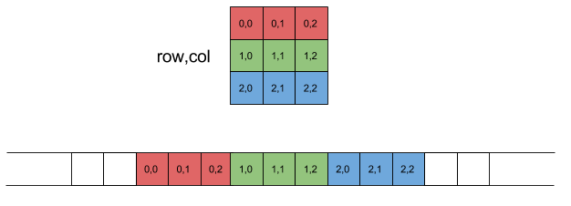
Row Major
Offset required for accessing element of row index row and column index col can be represented by following equation:
Offset=row * NumCols + col
Where, NumCols is the number of columns per row in the matrix. It is easy to see this equation fits the linear layout in the diagram shown above.

2D column-major:
Column-major order same as row-major replacing every appearance of "row" by "column" and vice versa. The first column of the matrix is placed in first contiguous block of memory, then the second column in second contiguous block of memory, and so on:
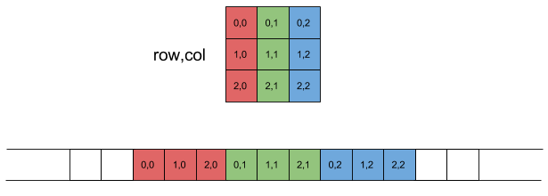
Column Major
The offset of an element in column-major layout can be found using this equation:
Offset=col * NumRows + row
Where, NumRows is the number of Rows in the matrix.

Exercise 1:
Write a C++ code to copy data of a 2D array in a 1D array using Row Major Order.

Exercise 2:
Using the abstract data Type of a Matrix given below, write a program that
- Input a matrix in 2D array
- Map this array in 1D array using Column major order
- Input second matrix in 2D array
- Map this array in 1D array using Column major order.
- Now perform matrix multiplication on these 1D arrays
- Save the result back in a 2D array.

Implement this question for any number of rows and columns using class “matrix”.

#include<iostream>
using namespace std;
class matrix
{
int **p;
int r;
int c;
int *colmajor;
int *multiply1D;
public:

matrix(int row, int col);
// Constructor

void disp2D();
// displays the elements of **p

void dispColMajor();
// converts 2D into 1D using column major
//and displays the elements of column Major Order //Matrix

void Multiply_colMajor(matrix & t);
// Multiplies Matrices in column major order and save the result in a 1D dynamic array

void colMajor_2D(matrix & t);
// Maps the elements stored in row major order to
// the 2D array and print the results
~matrix();
// Destructor
};
void main()
{
matrix a(4,3);
matrix b(3,4);
a.disp2D();
a.dispColMajor();
b.disp2D();
b.dispColMajor();
a.Multiply_colMajor(b);
a.colMajor_2D(b);

}

matrix::matrix(int row,int col)
{
r=row;
c=col;
p = new int*[r];
for(int i=0;i<r;i++)
{
p[i]=new int[c];
for(int j=0;j<c;j++)
p[i][j]=(2*i+j);
}
}

POST LAB(7 marks in Lab Report):
Using Node Voltage method, Generate 3 equations, write code to input the data from user and display the data in the form of Matrix on Screen using Row Major Order, then Solve the matrix to get the value of V1, V2 and V3. Your Code should be generic. Solve the matrix using any of the following method
- Gaussian Elimination
- Crammer Rule
  - Convert the matrix in lower or upper diagonal matrix. Multiply diagonal entries to find determinant of matrix.
- Inverse of a Matrix
- Solving equations in Matrix Form
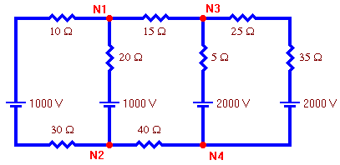

Electric Circuit
We will choose node 4 as the reference node and assign it a voltage of zero.

